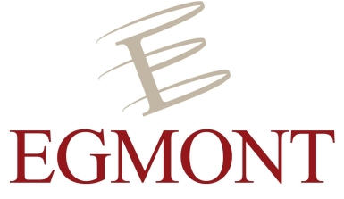

Event report – International Conference: The implementation of the EU Strategic Compass

Wednesday, 6 April 2022 – Egmont Palace, Brussels

On Wednesday, 6 April 2022, the Clingendael and Egmont Institutes organised an International Conference on “The Implementation of the EU Strategic Compass”, just over two weeks after the EU Ministers of Foreign Affairs and Defence had agreed on the document (21 March). With its formal adoption by the European Council on 25 March, the Strategic Compass marked a milestone for the EU’s role in security and defence. The Compass seeks to provide the EU with guidance so that it can become a more mature actor in security and defence, something which has become ever more urgent in light of the return of war to the European continent. It outlines concrete objectives in four areas: crisis management operations (act), resilience (secure), capability development (invest) and partnerships.

Now that the Compass has been adopted, the EU is immediately faced with the next challenge: implementation. The question that arises is: how to ensure that the Strategic Compass becomes a success? The International Conference contributed to this debate, focussing in particular on the realisation of the EU Rapid Deployment Capacity (act) and on the elaboration of the Hybrid Toolbox (secure). The Conference kicked off with keynote speeches from the Ministers of Defence of the Netherlands, Kajsa Ollongren, and of Belgium, Ludivine Dedonder, followed by two panel discussions on the two specific themes of the EU’s Rapid Deployment Capacity and the EU’s Hybrid Toolbox.

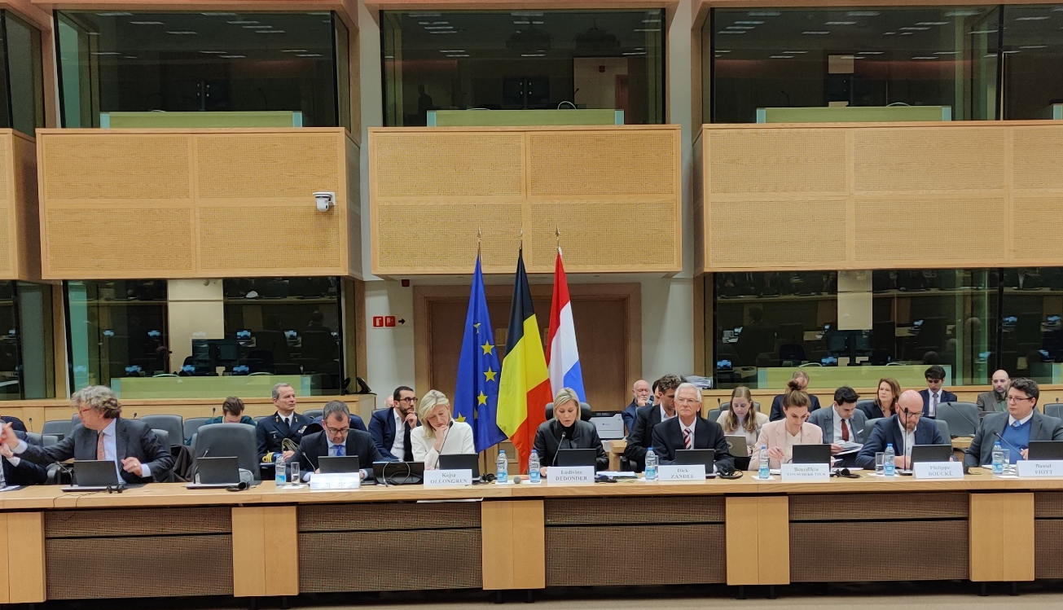

Keynote speeches
In their keynote speeches, the Dutch Minister of Defence Kajsa Ollongren and her Belgian colleague Ludivine Dedonder stressed the importance of the successful implementation of the Strategic Compass for the EU’s role in security and defence. According to Ollongren, the return of war in Europe has “catapulted the EU into its role as a geopolitical actor”. The Russian invasion of Ukraine “reminds us of the founding narrative of the European project: peace, prosperity and security. It has made clear that we cannot and should not take freedom and peace for granted. That freedom comes at a price that we should be willing to pay”.

Ollongren and Dedonder outlined that the EU and its member states, including the Netherlands and Belgium, are taking big steps on EU defence. Ollongren stated that the Strategic Compass is leading the way in this regard, in order to strengthen the EU’s capacity to act and protect. She announced that the Netherlands will contribute to the Rapid Deployment Capacity (RDC) in 2025, with “a 150-strong manoeuvre unit that operates with Boxer fighting vehicles and has its own medical support capability”. The RDC will have to be fully operational in that year, with Germany as the first lead nation.

Click here for the speech by the Dutch Minister of Defence, Kajsa Ollongren.

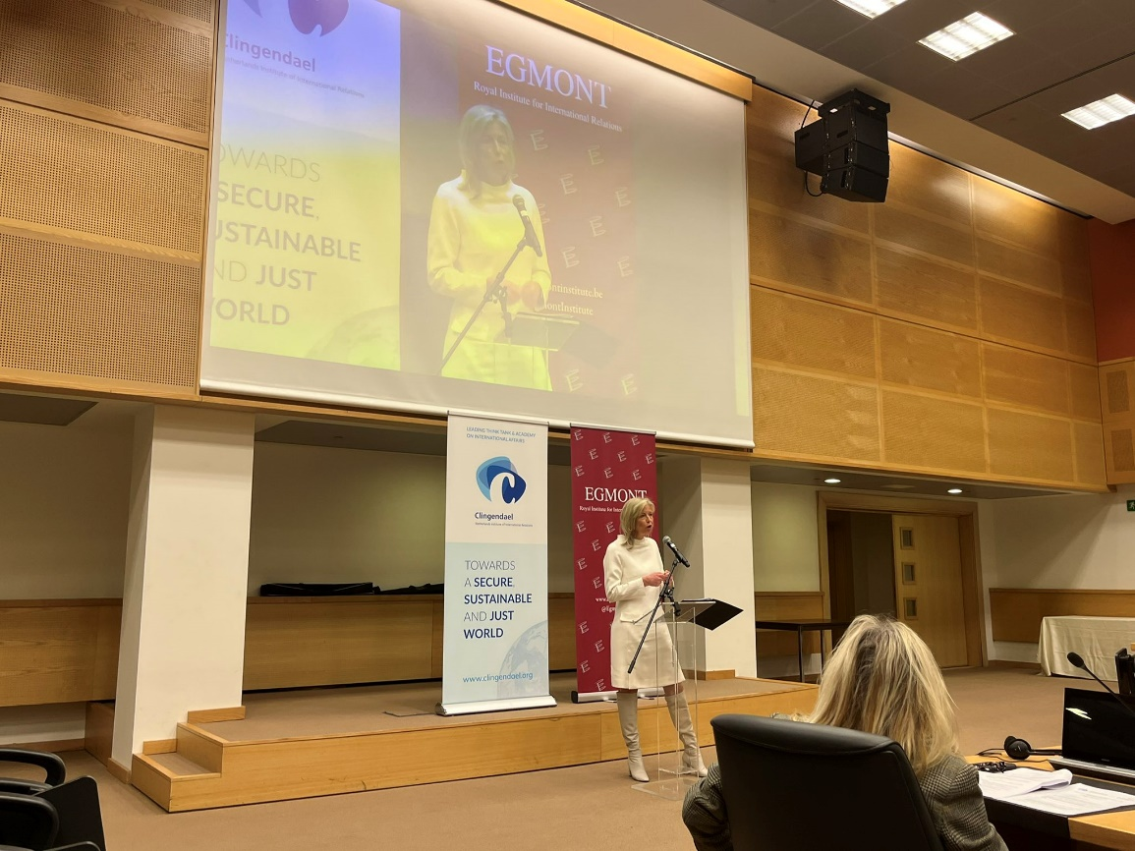

Panel 1: the EU Rapid Deployment Capacity (RDC)
The fist panel, moderated by Clingendael’s Head of the Security Unit Dick Zandee, was dedicated to the RDC: a flagship initiative of the Strategic Compass. The RDC has to generate a force structure of a maximum of 5,000 troops that should allow the EU to be able to act promptly in all domains, including air, land, maritime, cyber and outer space. It should provide the EU with the capacity to act independently, especially when it comes to security risks in its own neighbourhood. There are, however, still some question marks surrounding the RDC. In this panel, Benedikta von Seherr-Thoß (Federal Ministry of Defence of Germany), Philippe Boucké (Major-General (Ret.) of the Belgian Army) and Daniel Fiott (European Union Institute for Security Studies) discussed the necessary preconditions for a successful RDC and the challenges that the EU member states will face in the next few years in order to make the RDC a reality.

As for the requirements, the panellists put forward political, military and economic factors that are of importance for the RDC to become a success. The panellists concurred that keeping political pressure, maintaining clear communication with national parliaments and the public as well as close interaction between the political, military and operational sides are essential. With respect to the military domain, the presence of clear and robust tasks and mandates, advanced planning, training and exercises were regarded as crucial elements for the RDC to be successful. At the economic level, sufficient financial contributions by the EU member states were regarded as important. But, in trying to comply with these requirements, the panellists also identified several obstacles that EU member states need to overcome: the slow decision-making processes, the lack of adequate and sufficient capabilities (in particular strategic enablers), addressing the single set of forces principle by seeking a right balance between the EU and NATO, and maintaining political momentum.

Panel 2: the EU’s Hybrid Toolbox
The EU Hybrid Toolbox, to be developed in the near future, was the theme of the second panel, moderated by the Egmont Institute’s Director of the EU in the World, Sven Biscop. In a world in which security threats are becoming more complex and, to an increasing extent, of a hybrid nature, it is crucial that states are capable of countering these threats. Addressing these threats is primarily a member state responsibility, but there is a role for the EU in facilitating that member states coordinate their counter-hybrid efforts and responses in case they fall victim to a hybrid attack. In this panel, Joanneke Balfoort (European External Action Service), Margriet Drent (Ministry of Defence of the Netherlands) and Kenneth Lasoen (Clingendael Institute) addressed how the EU should tackle hybrid threats and what the Hybrid Toolbox should look like.

Hybrid threats typically have a cross-sectoral character and are not restricted to the area of defence: many potential targets of hybrid threats, like critical infrastructure, are in the hands of the private sector, making it essential to apply a wide approach in designing counter-hybrid policies. Therefore, the panellists highlighted the importance of a whole-of-government and a whole-of-society approach in addressing hybrid threats. The panellists emphasised that this already occurs both within the EU (a multi-stakeholder approach) as well as at the national level. The EU’s Hybrid Toolbox takes this explicitly into account. Moreover, the EU Hybrid Toolbox will be comprised of preventive measures, cooperative measures, stability-building measures, restrictive measures, and mutual assistance and solidarity measures. The importance of these diverging measures was underlined, but also the essence of looking through the eyes of potential adversaries, instead of primarily seeing hybrid threats from the victim’s perspective. The discussion also touched upon the need to strike an effective balance between on the one hand upholding our values and way of life, and on the other hand addressing the key vulnerabilities that stem from exactly these freedoms. This includes the dilemmas that arise when building resilience through countering disinformation, safeguarding economic security and allowing security services to act against undue foreign interference in electoral processes.

Conclusion
The International Conference with a wide participation of representatives of EU member states, institutions, the defence industry, media and think tanks provided useful insights into how a successful implementation of the Strategic Compass can be achieved. The current security reality with the return of war in Europe leaves no other choice than to implement the Strategic Compass according to its ambitious timelines. As the implementation of the Compass is member-state driven, it will be of paramount importance that the EU member states demonstrate the necessary political will to actively engage themselves in the implementation process by together addressing key issues such as speeding up decision-making, closing the capability shortfall gaps and being better prepared for ‘acting’ and ‘securing’ – in particular by conducting exercises. Naturally, political willingness has to be backed up with adequate budgets and collaborative investment. The upcoming years will prove whether the EU and its member states will be able to square its ambitions with actions and become a more mature and self-reliant actor in the area of security and defence.

